The Bartlett School of Environment, Energy and Resources

MSc ESDA Title Page

UCL Candidate Code: HZYC1
Module Code: BENV0092
Module Title: Energy Analytics in the Built Environment
Coursework Title: Predictive analysis for aggregated smart meter data
Module Leader: Despina Manouseli
Date: 20/04/2024
Word Count: 2263 excluding references.

By submitting this document, you are agreeing to the Statement of Authorship:
I/We certify that the attached coursework exercise has been completed by me/us and that each and every quotation, diagram or other piece of exposition which is copied from or based upon the work of other has its source clearly acknowledged in the text at the place where it appears.
I/We certify that all field work and/or laboratory work has been carried out by me/us with no more assistance from the members of the department than has been specified.
I/We certify that all additional assistance which I/we have received is indicated and referenced in the report.
Please note that penalties will be applied to coursework which is submitted late, or which exceeds the maximum word count. Information about penalties can be found in your Course Handbook which is available on Moodle: https://moodle.ucl.ac.uk/course/view.php?id=29435&section=0

- Penalties for late submission
- Penalties for going over the word count

In the case of coursework that is submitted late and is also over length, then the greater of the two penalties shall apply. This includes research projects, dissertations and final reports.

Predictive analysis for aggregated smart meter data
Introduction
According to the Paris agreement The UK government have set plans to reduce emissions to a net zero by 2050 and one of the major emissions sectors are the built environment sector such as offices and homes, this essay will mainly look at the electricity consumption of the aggregated smart meter data of 13,000 homes across the UK.
The data is collected by the Smart Energy Research Lab of UCL, the data consists of variation of gas and electricity use in British dwellings and how it varies with region, external temperature, occupancy, local deprivation (as measured by Index of Multiple Deprivation), building size, age, form, EPC, heating system, and presence of solar panels (PV) and electric vehicles (EV).
This essay aim is to employ predictive analytics to understand and forecast household electricity consumption patterns. This analytical pursuit is driven by the need to optimize energy distribution and consumption, which is crucial during the decarbonising of the UK with the challenges of energy sustainability and climate change. By identifying key factors that influence electricity usage—ranging from household characteristics and occupant behaviours to psychological factors and energy-saving practices—this research explores the interface between human activity and energy efficiency.
The significance of building a predictive model lies in its ability to decode the complex dynamics of energy demand across various scales—from individual dwellings to entire regions. By analysing how building characteristics, regional climates, and the integration of energy-efficient technologies impact electricity consumption, this research aims to pinpoint the most effective strategies for energy management and reduction. Ultimately, understanding these multifaceted influences helps in formulating more precise and impactful energy policies and interventions, thereby not only minimizing the energy footprint of buildings but also advancing sustainability objectives. This analysis not only deepens our understanding of energy consumption patterns but also showcases the transformative potential of data-driven approaches to enhance energy efficiency systematically and sustainably.

Literature review
The research conducted by Anderson et al. (2017) explores the feasibility of using smart meter data to infer household characteristics, which could potentially replace traditional methods. They highlight how temporal load profiles can predict characteristics like household size, occupancy, and socio-economic status, which are crucial for energy demand management. This aligns with the findings of the Smart Energy Research Lab at UCL, which also emphasizes the importance of household characteristics in understanding energy consumption patterns.
There are many methodologies that can be employed to analyse smart meter data effectively. The review by McKenna et al. (2015) discusses linear and panel regression models as traditional methods used to forecast electricity consumption, focusing on their simplicity and effectiveness in handling large datasets. These methods are complemented by machine learning techniques that offer robust predictions and insights into consumption patterns, suggesting a multi-faceted approach to data analysis that incorporates both statistical and computational models.
While the potential of smart meter data in transforming energy management systems is widely acknowledged, significant challenges remain. These include technical issues related to data volume and complexity, as well as privacy concerns associated with detailed user data. The review by McKenna et al. (2015) specifically notes the need for advanced analytics to handle the high granularity of smart meter data, which is essential for accurate load forecasting and management. Furthermore, the paper by Anderson et al. (2017) discusses the implications of using smart meter data for societal benefits, such as improving energy efficiency and reducing carbon emissions, while also considering the privacy implications of detailed household energy usage data.
Methodology
Data Preparation
The initial dataset sourced from the Smart Energy Research Lab at UCL Few, J (2021) comprises 109,990 rows and 21 columns. A critical observation during the preliminary analysis was the presence of superfluous variables that do not contribute significantly to the study's objectives. For instance, variables such as gas usage, standard deviation, and the 75th percentile data points are excluded. The rationale for this decision lies in focusing the analysis strictly on electricity consumption patterns, thereby reducing noise and enhancing the model's interpretability and efficiency. This step of removing irrelevant data aligns with recommendations by Witten et al. (2016) on data preprocessing for predictive modelling.
Once the dataset is streamlined, it is divided into training and testing sets. This split is crucial for validating the model on unseen data, thereby ensuring that the predictions are robust and applicable in real-world scenarios. Consistent with common practices in machine learning, a split ratio of 70:30 will be used for the training and testing sets respectively, as recommended by James et al. (2013).

For predictive modelling in this study, two primary methods are utilized: linear regression and panel regression.
Linear regression
A Linear regression model is chosen for its simplicity and interpretability, which makes it an ideal baseline model. It allows for the direct quantification of the relationship between independent variables such as building characteristics and the dependent variable electricity consumption.
The implementation of linear regression involves fitting a linear equation to observed data to predict the values of an outcome variable from one or more explanatory variables, assuming that the relationship between the variables is linear.

Pannel regression
Pannel regression model is used to capture both cross-sectional and time-series variations, making it highly effective for longitudinal data like smart meter readings. This method is selected to explore how both time-invariant and variant factors namely segmented variable and their values influence energy consumption across different households.

model selection and backward selection.
Due to the complexity and high dimensionality of datasets with numerous independent variables, manually selecting the most effective variables for a model can be challenging and inefficient. Effective model selection is crucial to ensure that the resulting models are not only accurate but also interpretable and manageable. To address this challenge, both automated and manual model selection methods, backward stepwise selection, coupled with statistical testing and diagnostic checks, provides a robust framework for developing predictive models, especially in this scenario which involves complex datasets with many variables. This method ensures that the final model is both efficient and interpretable, making it particularly suitable for fields like energy consumption where finding the influence of various factors is crucial for effective management and prediction.
Backward stepwise selection is an effective automated method for constructing regression models when confronted with datasets that include a vast array of independent variables. This technique is particularly advantageous because it methodically eliminates the least significant predictors, thereby simplifying the model without sacrificing its predictive accuracy. This approach is widely utilized due to its ability to efficiently manage complexity and focus on the most impactful factors, enhancing the interpretability and generalizability of the model.
The process of backward stepwise selection starts by including all available predictors in the initial model setup. Each variable's significance is evaluated based on statistical metrics, primarily using the p-value to assess the importance of each predictor. Variables that exhibit high p-values — suggesting a lack of statistical significance — are incrementally removed from the model. This removal process continues iteratively, with the model being refitted after each variable's exclusion, until no further variables can be removed without a detrimental impact on the model's performance. This methodology helps prevent overfitting, maintaining a balance between model accuracy and complexity.
Statistical tests and criteria play a critical role in this selection process. Adjusted R² is particularly valuable as it provides a measure of the model's explanatory power adjusted for the number of predictors, penalizing the addition of non-informative variables. The Bayesian Information Criterion (BIC) and Akaike Information Criterion (AIC) are also crucial; they are used to balance the model's fit against its complexity, with lower values indicating a more favorable model. These criteria are instrumental in guiding the selection process by quantifying the trade-offs between the complexity of the model and the accuracy of its predictions (James et al., 2013).
Diagnostic plots are integral to the validation phase. The Residual vs. Fitted plot checks for homoscedasticity and linearity, fundamental assumptions of regression analysis. A well-specified model should display residuals scattering randomly around the central axis. The Q-Q plot is employed to verify the normal distribution of residuals, a prerequisite for many inferential techniques used in regression analysis. These plots are essential tools for diagnosing model issues and confirming that the underlying assumptions of the regression analysis are met.

Results
Linear regression model result
There are 2 main different models one is normalised and other is not normalised the two models produces similar results in the predicted against actual value as seen in figures 1 and figure 4, so in order to determine which model to use the residual vs fitted plot can show goodness of fit for a mode as shown in figure 2 and figure 5, the results of both model shows that the red line is a slight curve however it does not deviate from the 0 line too far suggesting both model are unbiased, the model also show similar outliers such as the points (12490, 13330, 13210), another way to find best model is the Q-Q plot shown in figure 3 and figure 6, both figures shows that the points is close to the dotted line until 2 Theoretical Quantiles where the points start to deviate and curve upward suggesting that the residual are not perfectly normally distributed and that there may be outliers or extreme values present in the data. And finally, the AIC of non-normalised model produces a value of 8925.3 where as a normalised model produces a AIC of 8822 suggesting that the normalised model is slightly better therefore when doing the panel regression the data will be normalised
Non-normalised linear regression model

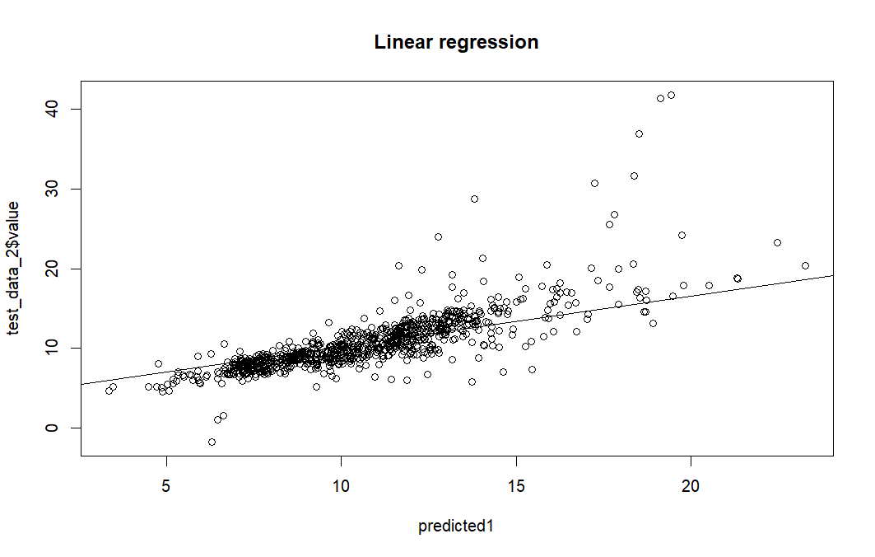
Figure 1: linear regression predicted against actual graph
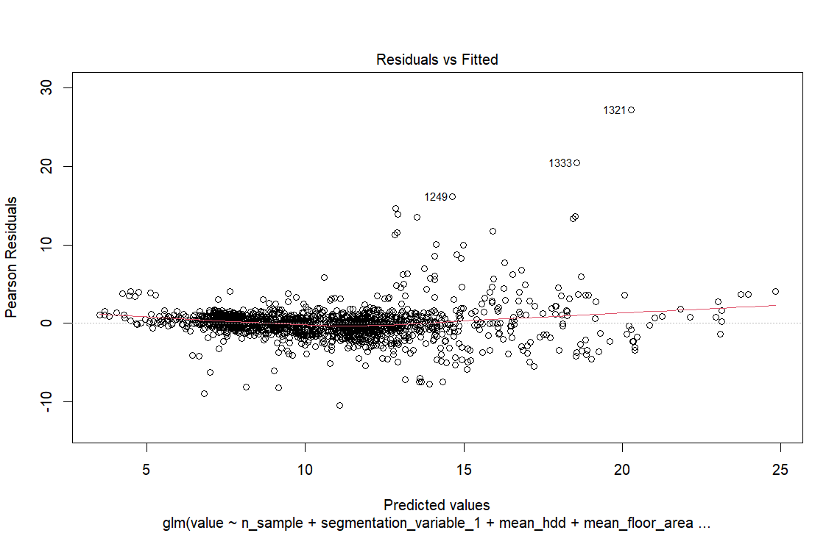
Figure 2: non normalised residual vs fitted graph
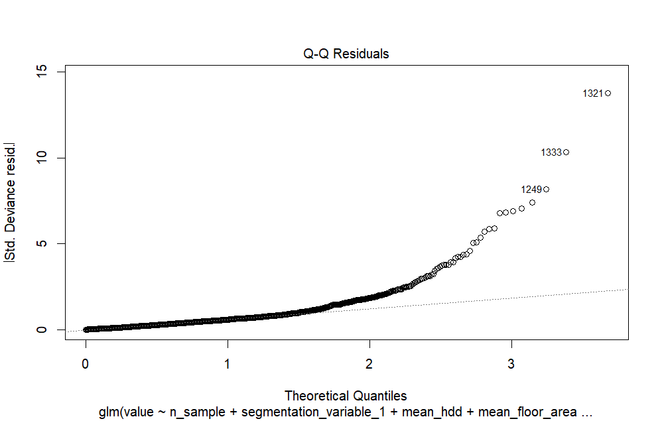
Figure 3: non normalised model Q-Q plot
Normalised linear regression model

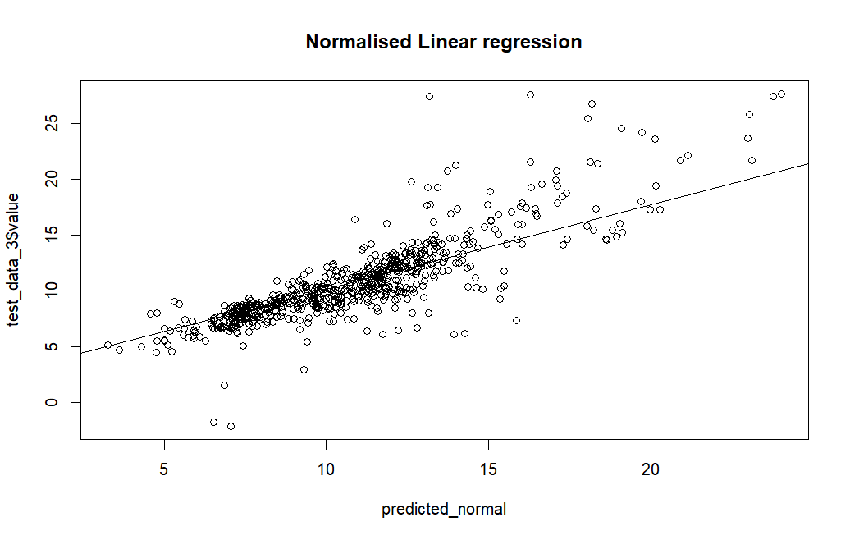
Figure 4: Normalised linear regression predicted vs actual

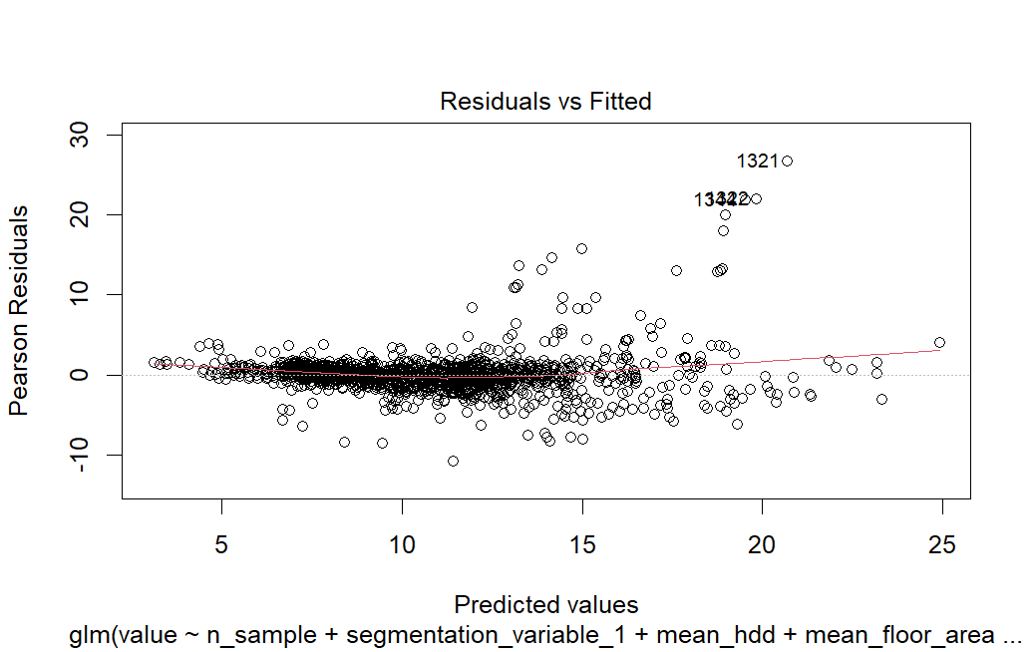
Figure 5: non normalised residual vs fitted graph

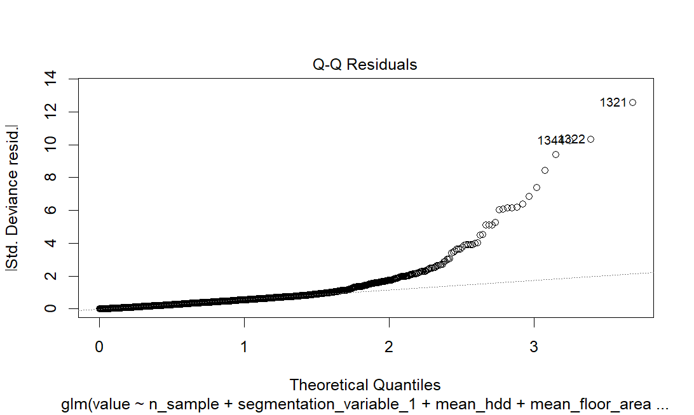
Figure 6: normalised model Q-Q plot
Pannel regression model
The Pannel regression used contains 3 models the fixed, pooled and random model in order to determine the best model to be used for forecasting the F test, Hausman Test and other metrics such as R squared are compared to find the mode with the best fit.

Fixed effects, 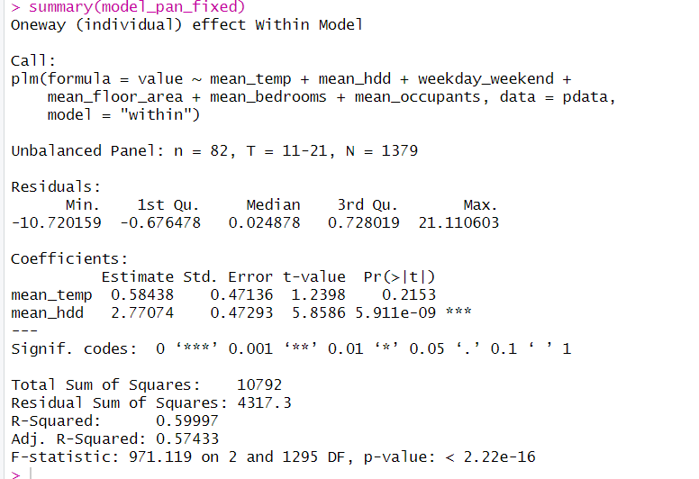
Figure 7: summary of fixed pannel regression model
Random effects,
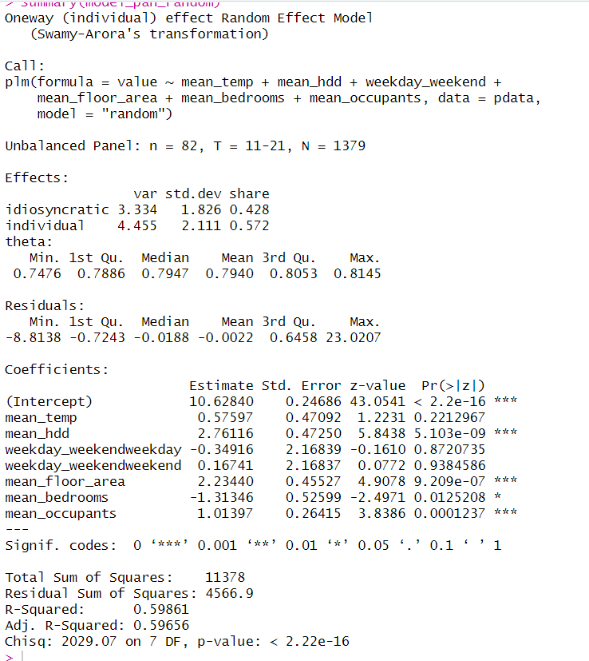
Figure 8: summary of random effect pannel regression model

pooled OLS mode 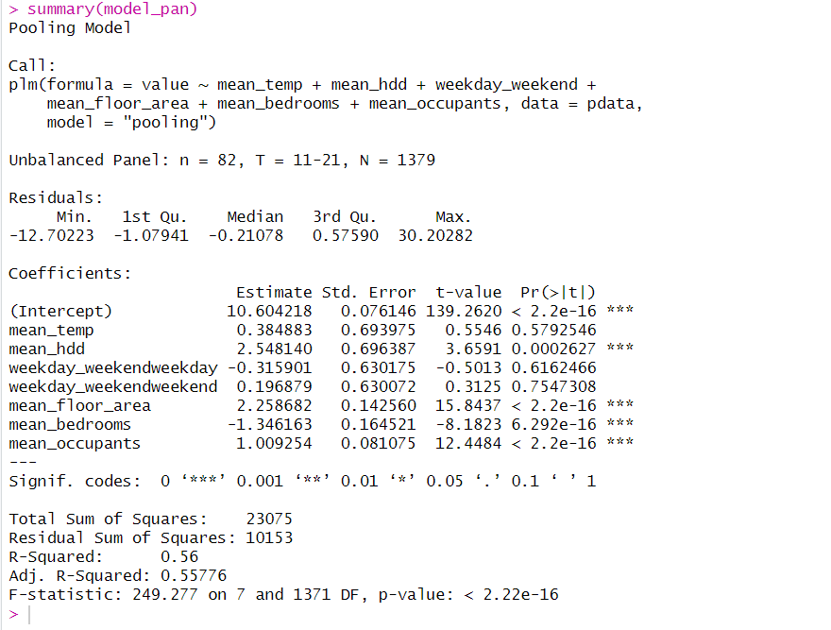
Figure 9: summary of pooled pannel regression model

Model selection for prediction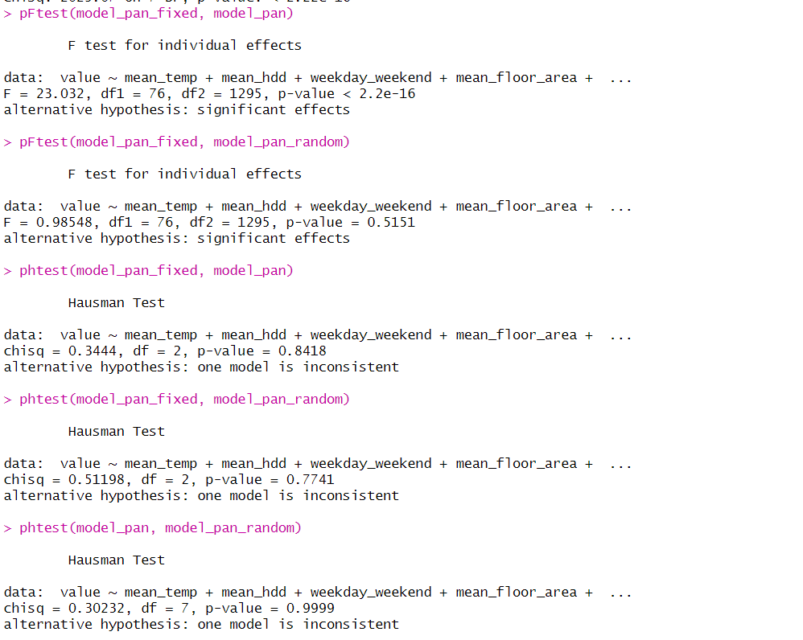
Figure 10: Hausman Test results

looking at the summary of the panel regression models we can see that figure 7 the fixed regression model have the highest adjusted r squared and r squared with the random effect model figure 8 as the second however other comparisons need to be made before reaching a conclusion there for using the Hausman test in figure 10.
The Hausman test is used to determine which model is more appropriate between fixed effects and pooled OLS model:
The null hypothesis of the Hausman test is that the preferred model is random effects, and the alternative is that the fixed effects model is preferred due to correlation between the unobserved effects and the explanatory variables. A p-value of 0.826 suggests that we fail to reject the null hypothesis, implying that the random effects model may be consistent, and the fixed effects model may not be necessary.
The second Hausman test is reported comparing the fixed effects model and the random effects model. And again, the test yields a high p-value of 0.8157, suggesting that the random effects model is not statistically different from the fixed effects model. This indicates that the random effects estimator may be consistent and efficient.
Knowing that the most appropriate models are the pooled effect and random effect the final Hausman test shows a p value of 0.9999 which suggests that the random effects model is not statistically different from the pooled effects model. This indicates that the random effects estimator may be the most consistent and efficient model to be used.

Using the random effect model, it can then be use it to predict electricity consumption values with the testing data. The result is as shown in figure 11 and figure 12. The shows that the predicted value is slightly different from the actual value however the difference is not much which suggests that It may have successfully captured the nuance of the data.
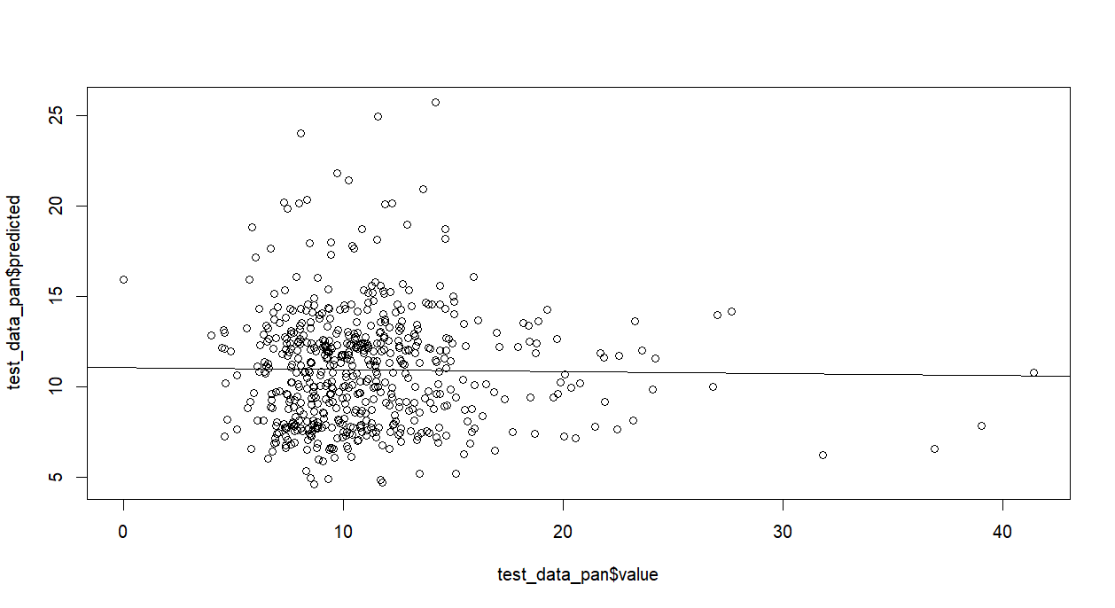
Figure 11: predicted vs actual
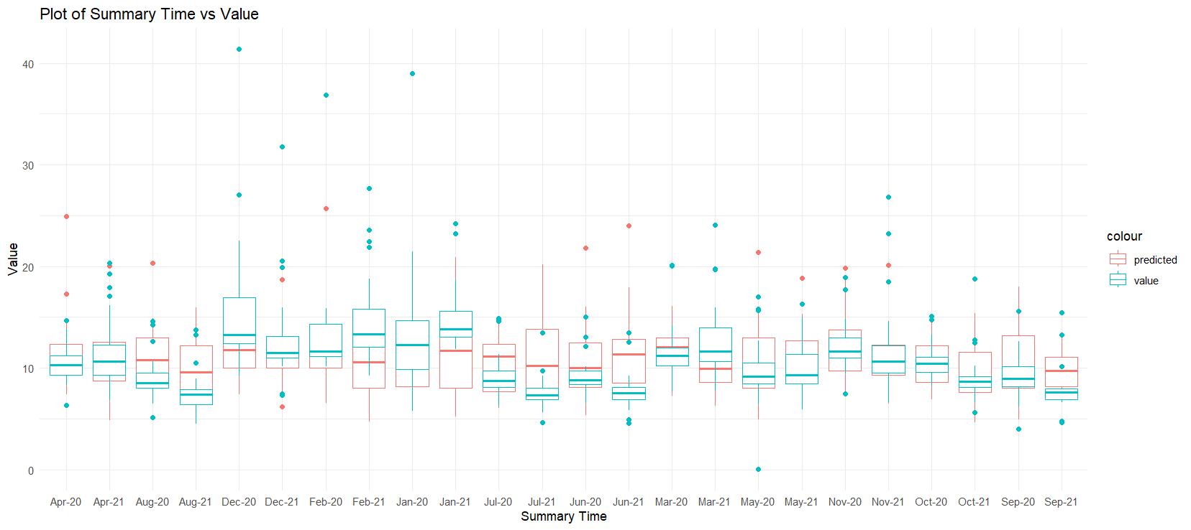
Figure 12: predicted and actual box plot

Conclusion
In conclusion this project has produces a successful linear and panel regression model that can effectively forecasts electricity consumption for UK households. This effort stands as a significant contribution to the ongoing conversation about energy efficiency and climate change policy, aligning with the goals set forth in the Paris Agreement. The model developed through this research offers valuable insights into electricity usage patterns and serves as a pivotal tool for energy management and policy recommendations, aiding the UK's government’s ambition to achieve net-zero emissions by 2050.
Dispute the model’s successes however due to the time constraints of the essay for further works and improvement on this project will be to include comparison of other regression methods such as, lasso and ridged regression, random forest with panel data or using deep learning to forecast electricity consumption, another thing that can be improved up on is the size of the data because after cleaning the data the remaining usable data are only 1/8 of its initial size and also because the data is aggregated the final model produced can not be fully relied on for a predicting individual households and can only provide an overview of possible outcomes

References:
Anderson, B., Lin, S., Newing, A., Bahaj, A.S. and James, P., 2017. Electricity consumption and household characteristics: Implications for census-taking in a smart metered future. *Computers, Environment and Urban Systems*, [online] 63, pp.58-67. Available at: <https://www.sciencedirect.com/science/article/pii/S0198971516300813> [29/03/2024].

McKenna, E., Richardson, I. and Thomson, M., 2015. Smart meter data: Balancing consumer privacy concerns with legitimate applications. *Energy Policy*, [online] 41, pp.807-814. Available at: <https://www.sciencedirect.com/science/article/pii/S0301421511009438 > [Accessed Date 07/04/2024].

Few, J., Pullinger, M., McKenna, E., Webbom, E. and Oreszczyn, T., 2022. Smart Energy Research Lab: Energy use in GB domestic buildings 2021. Smart Energy Research Lab (SERL) Statistical Reports, 1. London: Smart Energy Research Lab. Available at: <www.serl.ac.uk> [02/04/2024].

Witten, I.H., Frank, E., Hall, M.A. and Pal, C.J., 2016. *Data Mining: Practical Machine Learning Tools and Techniques*. 4th ed. Morgan Kaufmann. ISBN: 978-0-12-804291-5. [Accessed Date 12/04/2024].

James, G., Witten, D., Hastie, T. and Tibshirani, R., 2013. *An Introduction to Statistical Learning: with Applications in R*. Springer. ISBN: 978-1-4614-7137-0. [Accessed Date 06/04/2024].

